


PJT03030.R5.SAP.FS.DPP.ENH012.CSDD Updates for Enrollment Center | 

REVIEWER(S)
Name | Title | Department | Reviewed (date/time)
Manoj Ajgaonkar | SAP Solution Architect | SAP |  | <Date / Time>
Jack Hobbick | Testing Solution Manager | Smart Energy Program |  | <Date / Time>
Santhosh Shetty | Testing Lead | HCL |  | <Date / Time>
Jessica Scott | Audit Controls, Deloitte | Deloitte |  | <Date / Time>
Clark Oeler | Audit Controls, Deloitte | Deloitte |  | <Date / Time>
Chaitanya Kodela | BTS SDM Solution Architect | BTS |  | <Date / Time>
Nancy Pierce | Business Support Consultant | Virtual Contact Center |  | <Date / Time>
Abhishek Bansal | SAP Solution Architect | SAP |  | <Date / Time>
Ramesh Swarna | HCL Technical Lead | HCL |  | <Date / Time>

APPROVER(S)
Name | Title | Department | Approval (date/time)
Clay Engel | Enrollment Vendor Program Manager | Smart Energy Program | <Date / Time>
Krishna Karunakaram | Smart Energy Project Manager | Smart Energy Program | <Date / Time>
Jeff Yankley | IT-C&APS-IT App Portfolio-Front Office | BTS | <Date / Time>
Zach Pakkala | Business Support Consultant | Customer Operations/SE CORE | <Date / Time>
Blair Estep | CE Release Manager | Smart Energy Program | <Date / Time>

CONTRIBUTORS
Name | Organization | Area of Contribution
Matt Parker | Consumers Energy | DPP Enrollment
Ashish Bhargava | SAP | DPP Enrollment

VERSION HISTORY
Version | Date | Author(s) | Revision Notes
0.1 | 11/04/2015 | Matt Parker | Initial version

Table of Contents
REVIEWER(S) 2
APPROVER(S) 2
1 OBJECT REQUIREMENT SUMMARY 5
1.1 Object Information and Attributes 5
1.2 Requirements Summary and Business Driver 6
1.3 Assumptions 6
1.4 Current Functionality 6
1.5 Required Functionality 7
1.6 Project / Development Constraints 10
1.7 Performance Criteria 10
1.8 Other Objects Affected 10
1.9 External References 10
1.10 Definitions/Acronyms/Abbreviations 10
2 ENHANCEMENT DESIGN SPECIFICATIONS 11
2.1 Detail Requirements - Enhancement 11
2.2 Custom Class 14
2.3 Standard Rule 14
2.4 Custom Table Creation 14
2.5 Work Item Delivery Requirements 14
2.6 Triggering Events Determination 14
2.7 Escalation Requirements 14
2.8 Dependencies 14
2.9 Error Handling Method 14
2.10 Post Execution Notification Details 14
2.11 Process Log Details 15
2.12 Other 15
2.13 Unit Test Plan 15
2.14 Information Security 15
2.15 Audit 15
2.16 Questions / Issues / Risks 15

OBJECT REQUIREMENT SUMMARY

Object Information and Attributes

The following is current information about this object and document:
Object ID | CRM_ENH_DPP012
Title | PJT03030.R5.SAP.FS.DPP.ENH012.CSDD Updates for Enrollment Center
Team Which Owns the Object | SAP DPP Enrollment Team
System Version | CRM 7.0
Development Type | Enhancement
Priority | High
Estimated Complexity | High
Link to Process Flow

Requirements Summary and Business Driver
Ref. | PRICEFW ID | Enhancement Description
DPP-068 | CRM_ENH_DPP_004 | CSRs will have the ability to enroll customers in DPP (CPP and PTR) for both new move ins, and for already moved in customers. These enrollments will be offered to customers who have been previously enrolled in the DPP Program.

Alternatives to Object
Leave CSDD Enrollment out of the Enrollment Center making CSDD enrollments a different process than other SE Customer Programs which are being included in the Enrollment Center.

Impact of Implementation
If implemented, CSRs will be able to easily identify customer program eligibility for the programs included in the Enrollment Center, including the Customer Selects Due Date program. CSDD Enrollment/De-Enrollment initiation will be consistent with all other programs included in the Enrollment Center.

Impact of No Implementation
If not implemented, CE users would follow a different process for CSDD Enrollment/De-Enrollment than other SE Customer Programs. Users would have to continue to navigate to the Business Agreement view and initiate a Payment Term change in order to see whether or not the customer is eligible for the CSDD Program for all non-Move-In scenarios.

Assumptions
If a customer is currently enrolled on the CSDD program and requests a CSDD date change, CSRs will follow the existing process they use today to change Payment Terms by manually navigating to the Business Agreement view and clicking the Payment Term link as the Enrollment Center only includes functionality for program Enrollments and De-Enrollments.

Current Functionality
Currently the CSDD Enrollment and De-Enrollment process occurs after the user manually navigates to the Business Agreement view in CRM. Additionally, outside of the Move In process, CSRs are not able to clearly identify whether or not a Customer is eligible for the CSDD program until they navigate to the BUAG view and click the Payment Term link which at that time runs CSDD eligibility to identify whether or not the account is eligible for the program.

Required Functionality
In order to merge the Customer Selects Due Date program Enrollment and De-Enrollment functionality seamlessly into the Enrollment Center, the following changes are required:

Required Changes:
- Remove existing CSDD eligibility checks in CRM and Enrollment Prompt(s)Pop Ups at time of Move In
- Create new ‘Broad’ set of Eligibility checks at the time of Move In, and Pop Up to encourage user to access Enrollment Center
- Add existing CSDD eligibility checks (from ECC) to Enrollment Center
- Add functionality to the Enrollment Center to auto-navigate to the Business Agreement view – in edit mode - for CSDD Enrollment and De-Enrollment initiations
- Modify existing functionality to re-use the CSDD history logic displayed at Payment Term change to identify CSDD Enrollments and De-Enrollments for Enrollment Center History purposes.

Once these changes are incorporated, CSDD will be displayed consistently with all other customer programs included in the Enrollment Center. Additionally, initiation of CSDD Enrollment and De-Enrollment will also be the same as these other included programs. Once the Enrollment or De-Enrollment is initiated for CSDD from the Enrollment Center, all existing CSDD processing and functionality will remain unchanged.

Project / Development Constraints
None Identified.

Performance Criteria
None Identified.

Other Objects Affected
None Identified.

External References
None Identified.

Definitions/Acronyms/Abbreviations

EC | Enrollment Center
SAP | Systems, Applications & Products in Data Processing
CRM | Customer Relationship Management (Front Office SAP)
ECC | Enterprise Central Component (Back Office SAP)
CE | Consumers Energy
CSR | Customer Service Representative
CSDD | Customer Selects Due Date

ENHANCEMENT DESIGN SPECIFICATIONS

Detail Requirements - Enhancements
Enhancement Requirements
Number | Description of Requirement
1 | Remove existing CSDD eligibility checks in CRM and associated Enrollment prompt pop ups
2 | Creation of new broad set of eligibility logic to identify whether or not to display the Pop Up for Enrollment Center, and the creation of the EC Prompt Pop Up.
3 | Include existing CSDD eligibility checks from ECC in Enrollment Centers eligibility checks upon accessing the Enrollment Center
4 | Creation of logic to auto-navigate to the Business Agreement view upon CSDD Enrollment or De-Enrollment from the EC. Upon auto-navigating to the BUAG view, it should be rendered in Edit Mode immediately allowing the CSDD program change
5 | Modify the existing CSDD logic that currently calculates program history for Payment Term change message (ZRFC_BIBL_CSDD_ELIGIBLE lines 390 to 483) to be re-used when rendering the Enrollment Center to determine CSDD program history.

In order for the CSDD program to be included in the Enrollment Center for initiating Enrollment and De-Enrollment for the program, the following changes must be done.
- Remove existing CRM Eligibility checks and Enrollment Prompt Pop Ups:
Currently once a Move In is completed in CRM a set of CSDD eligibility checks are run in the background in CRM to determine whether or not to display a pop up which prompts the CSR to offer the CSDD program to the customer. If these checks determine that the customer is eligible for CSDD, a pop up is displayed to the CSR encouraging CSDD Enrollment.
Component – ZCMSUMMQA
Views - EBILLQ2YEF and ALLCONNECTQEF
Method – OFFER_CSDD. (This method checks to see if we can offer CSDD to them).

Since CSDD will be included in the Enrollment Center for initiating Enrollment, this functionality is no longer needed. The CRM CSDD eligibility checks should be removed, along with the associated CSDD Enrollment prompt pop ups that are displayed at the time of Move Ins.

- Creation of Enrollment Center Pop Up and Eligibility Rules:
Instead of creating individual program enrollment prompts for each new customer program, (CSDD, DPP, PrePay, etc.) we will create a new broad set of eligibility rules which will be run at the same time the existing CSDD ones are executed after the completion of a Move In. Once the Move In is completed, the system displays the “Collect Email” view in CRM which is when these new eligibility checks will be executed. If the account passes the eligibility checks (listed below) then an informational Pop Up should be displayed to the user with the following verbiage:
“Customer is eligible for customer programs. Please navigate to the Enrollment Center for details.”

Additionally, this informational pop up should include an “OK” button, that the user will click in order to close the pop up message.

Mock Up:
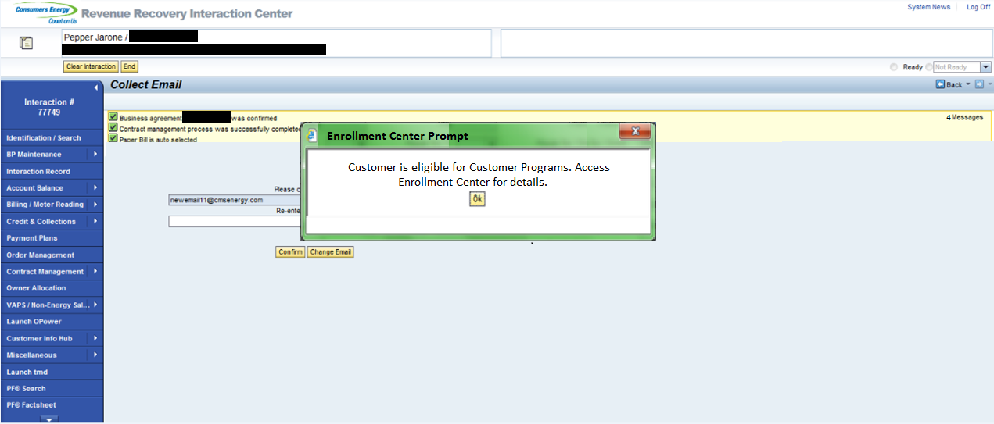

Enrollment Center Pop Up Eligibility Rules:
- Active Elec Meter Reading Over the Air: There must be an active installed meter capable of Over the Air reading.
Eligible Values:
EGERH-KOMBINAT = 'Z'
EGERH-AMS not space
EGERH-AMCG_CAP_GRP not space
TEAMI_AMCGCAP-AMCG_CAP = 3

- Add CSDD Eligibility checks to Enrollment Center:
Since the CSDD program will now be included in the Enrollment Center, the existing CSDD eligibility checks that reside in ECC (FM: ZRFC_BIBL_CSDD_ELIGIBLE) should be called upon accessing the Enrollment Center to determine whether or not the account is eligible for CSDD Enrollment. This should be called when the user attempts to access the Enrollment Center allowing the system to render the view displaying which programs the account is eligible for and which ones they are ineligible for.

- Logic to auto navigate to BUAG view in Edit mode:
Once an eligible CSDD Enrollment or De-Enrollment is initiated from the Enrollment Center, an enhancement is needed to automatically display the business agreement view in Edit Mode so that the user can click the Payment Term link allowing them to change the Payment Term as needed in order to complete the CSDD Enrollment or De-Enrollment.

- Logic to gather CSDD History for Enrollment Center:
By leveraging the existing CSDD logic which determines the number of times an enrollment has occurred in the last 12 months (created as part of CSDD R3 Functionality), and modifying it in order to gather the Business Agreements’ CSDD enrollment and de-enrollment history, the system will be able to identify any existing dates for the accounts CSDD Enrollments or De-Enrollments and display them accordingly in the Enrollment Center’s Program history section as applicable.

Technical Details of existing logic:
Program ZBIBIR_CSDD_LOAD_BALANCING - Lines 179-301.

There is a check on the current payment term in table FKKVKP field ZAHLKOND, and a check for planned change documents for that same field in case the enrollment has been performed but the effective date had to be delayed.

Note - This logic may need to be slightly modified in order to identify Enrollments or De-Enrollments if history is needed for greater than 12 months.

Custom Class
None Identified.

Standard Rule
None Identified.

Custom Table Creation
None Identified.

Work Item Delivery Requirements
None Identified.

Triggering Events Determination
None Identified.

Escalation Requirements
None Identified.

Dependencies
PJT03030.R5.SAP.FS.DPP.ENH011.Enrollment Center Functional Spec

Error Handling Method
None Identified.

Post Execution Notification Details
None Identified.

Process Log Details
None Identified.

Other
None Identified.

Unit Test Plan

Information Security
None Identified.

Information Classification
None Identified.

Security Roles (Profiles and Authorizations)
None Identified.

Table Security (if applicable)
None Identified.

ABAP Program Security (if applicable)
None Identified.

Audit
None Identified.

Questions / Issues / Risks
None Identified.

